**SQL Portfolio**

**CaseStudy Foodie-Fi**

**Github:** <https://github.com/adeeba234/SQL_Foodie-Fi_>

**Medium:** <https://medium.com/@adeebaamjad7/sql-case-study-foodie-fi-2aa86044c105>

# **Data Analysis Questions:**

1. **How many customers has Foodie-Fi ever had?**

select count(distinct customer_id) from subscriptions;

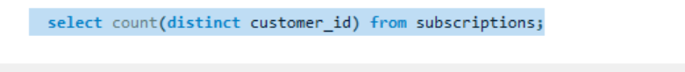

**Result:**

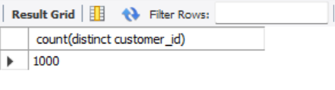

1. **What is the monthly distribution of trial plan start_date values for our dataset - use the start of the month as the group by value.**

select month(start_date)as months, count(customer_id)as num_customers

from subscriptions

group by months

order by months;

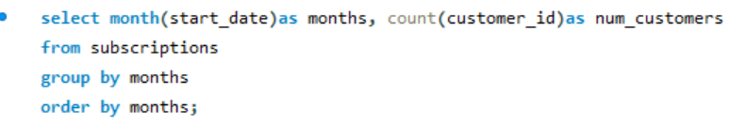

**Result:**

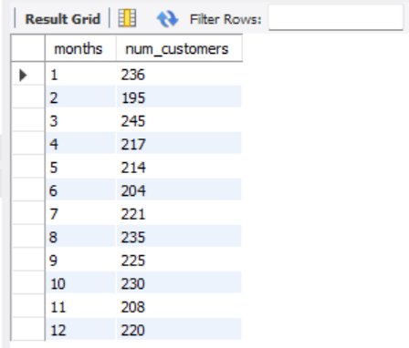

1. **What plan start_date values occur after the year 2020 for our dataset? Show the breakdown by count of events for each plan_name.**

select p.plan_name, p.plan_id, count(*) as total_count

from plans p

join subscriptions s

on s.plan_id=p.plan_id

where s.start_date >= "2021-01-01"

group by p.plan_id, p.plan_name

order by p.plan_id;

**Result:**

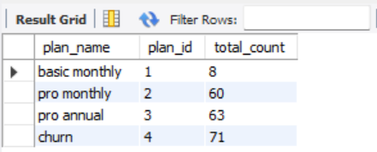

1. **What is the customer count and percentage of customers who have churned rounded to 1 decimal place?**

select count(*) as total_churn,

round(count(*)* 100/ (select count(distinct customer_id) from subscriptions),1) as percentage

from subscriptions

where plan_id=4;

**Result:**

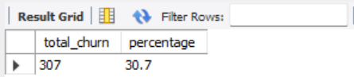

1. **How many customers have churned straight after their initial free trial - what percentage is this rounded to the nearest whole number?**

select plan_id,count(customer_id)

as count_customer,Round(count(customer_id)/(select count(customer_id)

from subscriptions),3)*100 as Percentage

from subscriptions

where plan_id=4 and customer_id

in(select customer_id from subscriptions where plan_id=0);

**Result:**

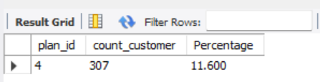

**6. What is the number and percentage of customer plans after their initial free trial?**

with next_plane_cte as (

select *, lead(plan_id,1) over(partition by customer_id order by plan_id) as next_plane

from subscriptions)

select next_plane,

count(*) as num_cust,

round(count(*)* 100/ (select count(distinct customer_id) from subscriptions),0) as perc_next_plane

from next_plane_cte

where next_plane is not null and plan_id

group by next_plane

order by next_plane;

**Result:**

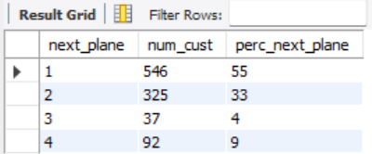

**7.What is the customer count and percentage breakdown of all 5 plan_name values at 2020-12-31?**

select plan_name,

COUNT(distinct customer_id) as customer_count,

ROUND (COUNT(distinct customer_id) / (select Count(distinct customer_id) from subscriptions)*100, 1) as percentage

from subscriptions

join plans on subscriptions.plan_id = plans.plan_id

where start_date <= '2020-12-31'

group by plan_name;

**Result:**

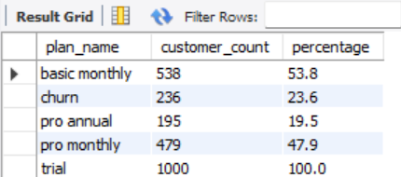

**8. How many customers have upgraded to an annual plan in 2020?**

select plan_name,count(customer_id)

as count from subscriptions

as sp join plans as p

on sp.plan_id=p.plan_id

where plan_name='pro annual'

AND year(start_date)='2020';

**Result:**

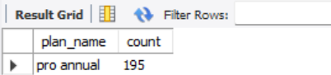

**9. How many days on average does it take for a customer to an annual plan from the day they join Foodie-Fi?**

select

round(avg(DATEDIFF(s2.start_date, s1.start_date)),0) as Avg_days_to_annual_plan

from subscriptions s1

join subscriptions s2 on s1.customer_id=s2.customer_id

where s1.plan_id =0

and s2.plan_id = 3

and s2.start_date > s1.start_date;

**Result:**

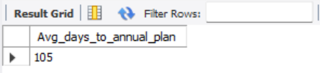

**10. Can you further breakdown this average value into 30 day periods (i.e. 0-30 days, 31-60 days etc)**

select

case

when Avg_days_to_annual_plan between 0 and 30 then '0-30 days'

when Avg_days_to_annual_plan between 31 and 60 then '31-60 days'

when Avg_days_to_annual_plan between 61 and 90 then '61-90 days'

else 'More than 90 days'

end as period,

COUNT(*) as customers_count

from (

select

DATEDIFF(s2.start_date, s1.start_date) as Avg_days_to_annual_plan

from subscriptions s1

join subscriptions s2 on s1.customer_id=s2.customer_id

where s1.plan_id = 0

and s2.plan_id = 3

and s2.start_date > s1.start_date

) as sub

group by period

order by period;

**Result:**

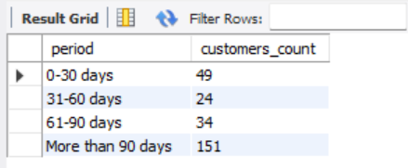

**11. How many customers downgraded from a pro monthly to a basic monthly plan in 2020?**

with next_plan as (

select *, lead(plan_id,1) over(partition by customer_id

order by start_date, plan_id) as plan

from subscriptions

)

select count(distinct customer_id) as downgrade

from next_plan np

left join plans p on p.plan_id = np.plan_id

where p.plan_name = "pro monthly" and np.plan = 1 and start_date < "2020-12-31";

**Result:**

